Group Members: Kin Wai Wong, Zhong Zhong

30)

First, map the Person, Employee, Password, EmailAddress, PersonPhone tables in the AdventureWorks database to the People table in WideWorldImporters.

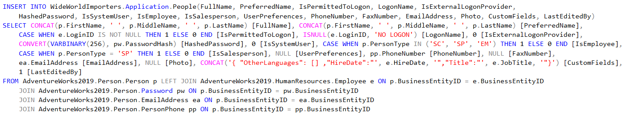

Then, map new product categories from the ProductCategory table in AdventureWorks to the StockGroup table in WideWorldImporters.

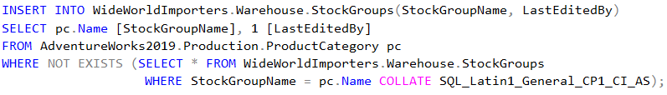

Next, map the new colors from the Product table in AdventureWorks to the Colors table in WideWorldImporters.



After that, map the vendor information in the Vendor table in AdventureWorks to the Suppliers table in WideWorldImporters.

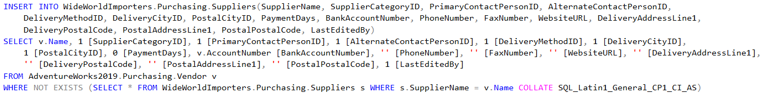

Next, map the needed information from Product, ProductVendor, Vendor, Suppliers, ProductModel, ProductModelProductDescriptionCulture, ProductDescription, ProductPhoto, ProductPhotoPhoto, Colors tables in AdventureWorks to the StockItems table in WideWorldImporters to create new StockItems for the new company.

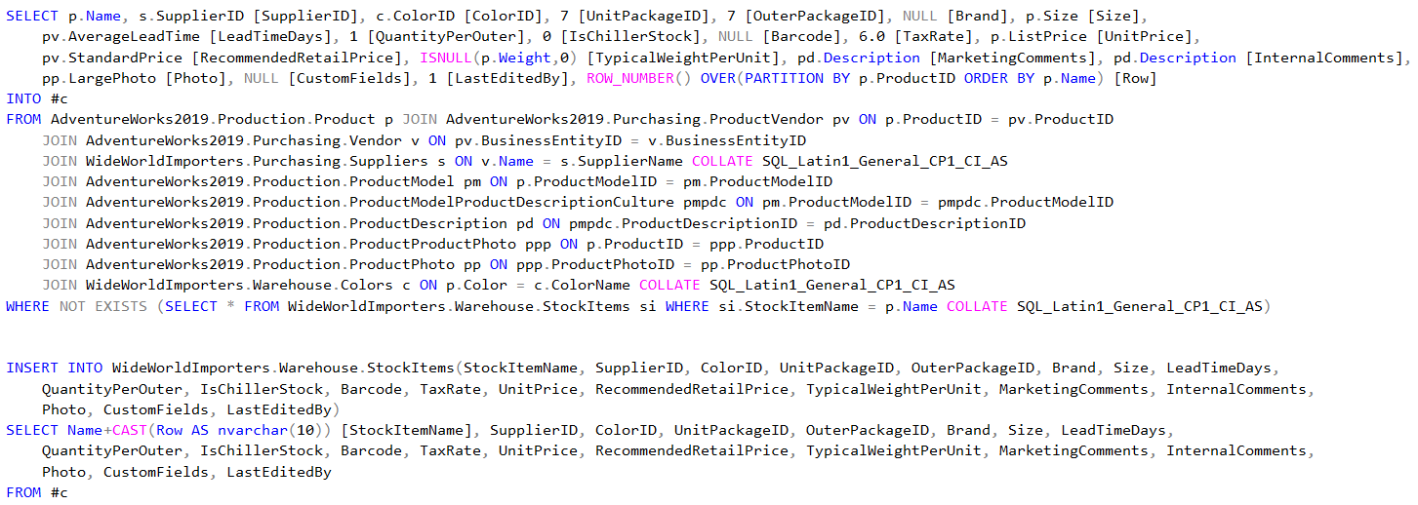

Finally, map the product and product category information from the Product and ProductSubcategory tables in AdventureWorks to the StockItemStockGroups in the WideWorldImporters table to create the relationships between new stock items and their stock groups.



31)

Entity Table: Bill, Patient, Insurance Company, Apparatus, CrewMember, Facility

Junction Table: BillCrewMember

Lookup Table: MedicalLevel_L, ApparatusType_L, FacilityType_L

